1. Admin Login Page:

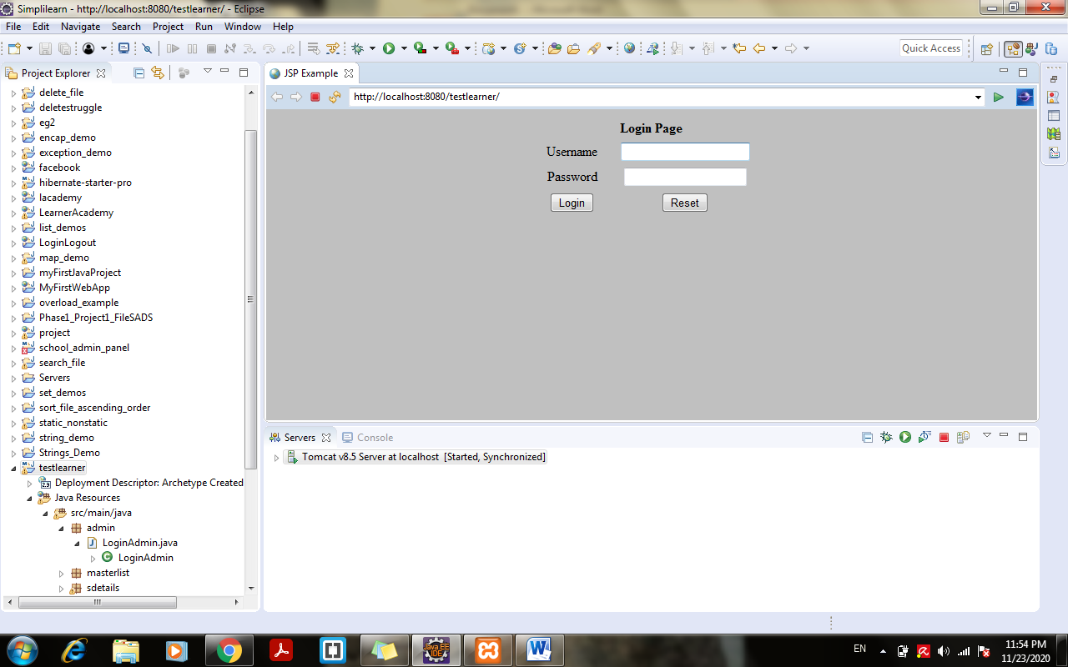

1. When entered wrong username and password:

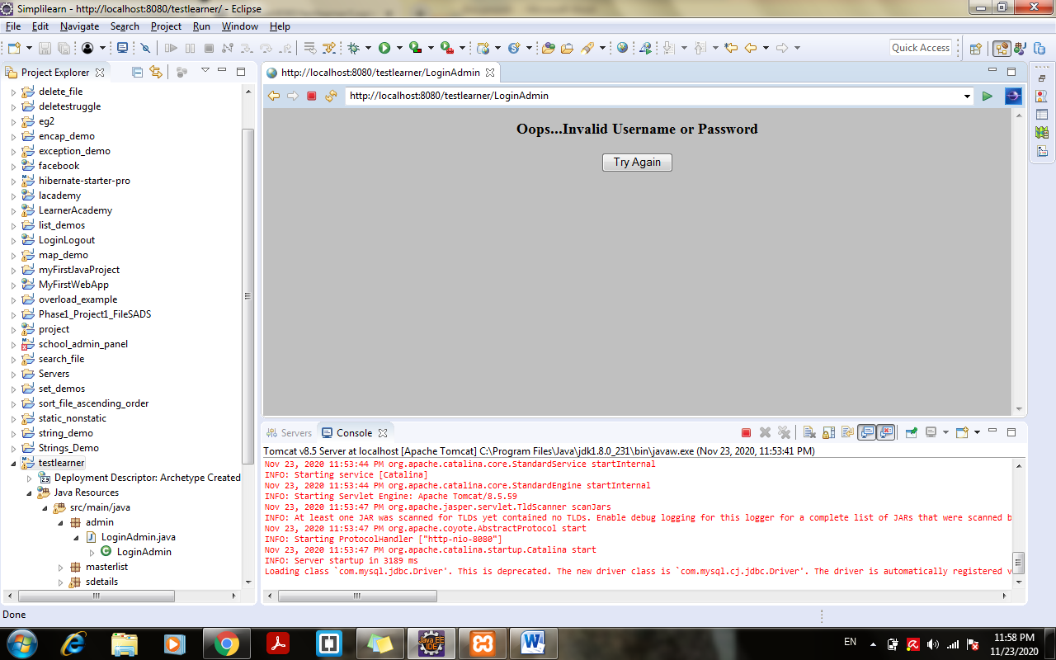

1. Admin Dashboard on successful login:

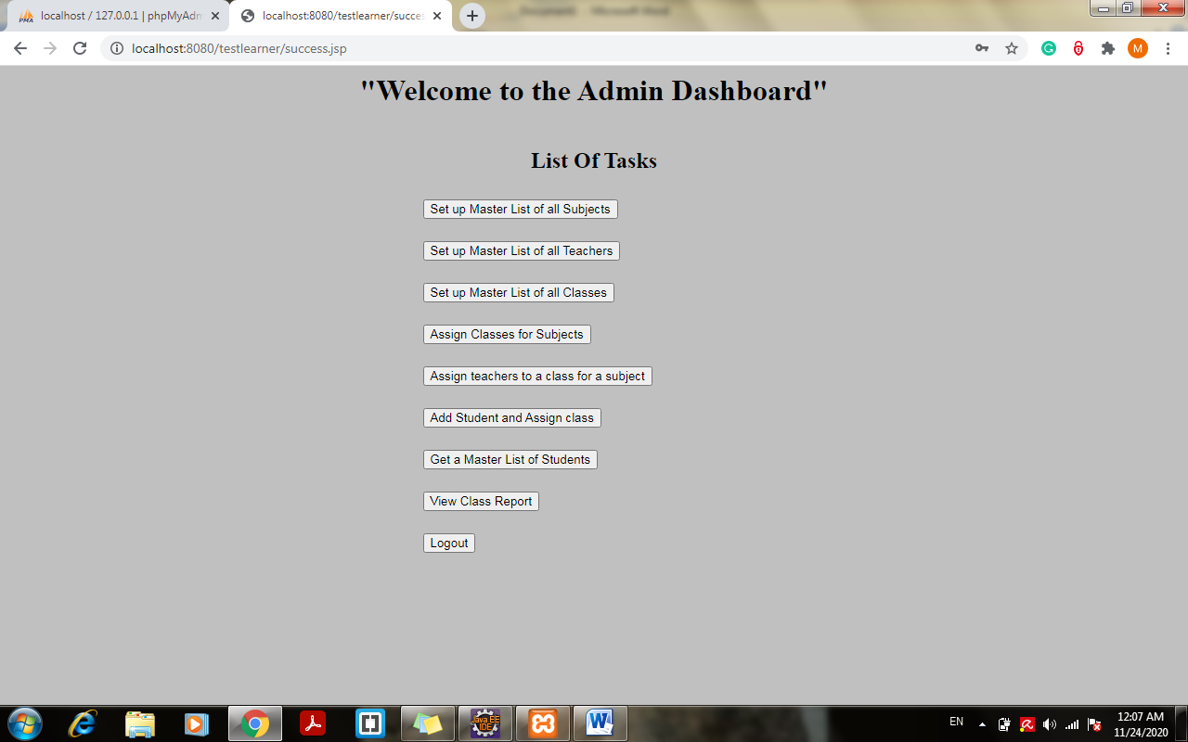

1. Click on setup master list of all subjects:

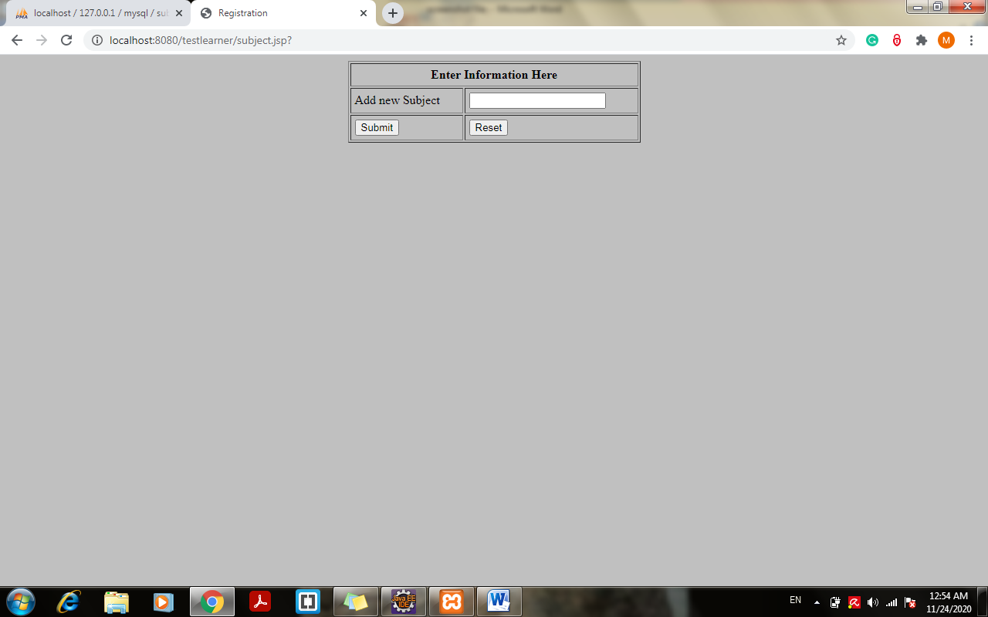

1. Improvisation in code for setting up master list of all subjects including some subjects with delete option:

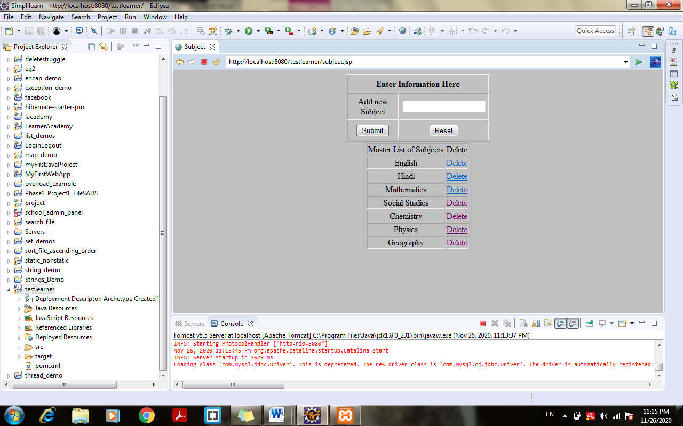

6. Try Deleting Subject example “Geography” > Click on delete :

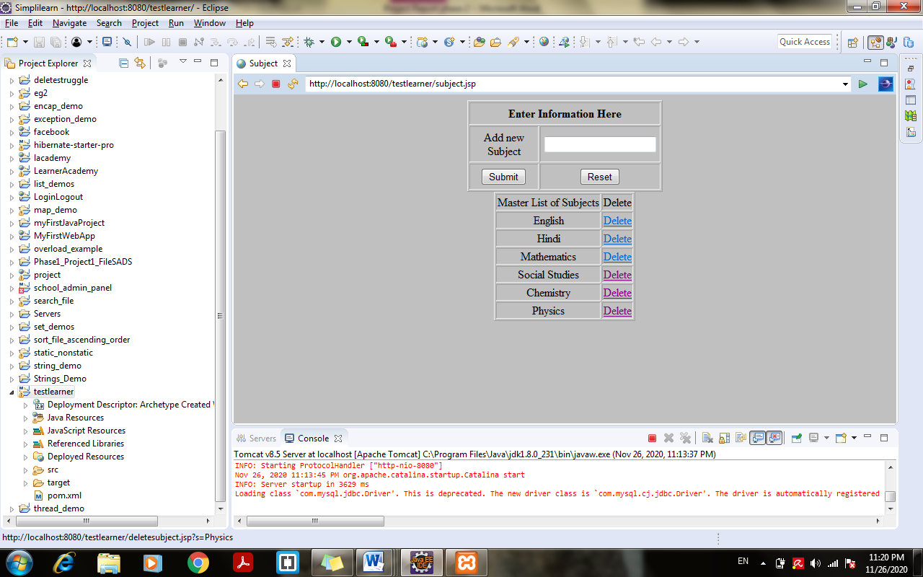

1. Enter Subject and click submit:

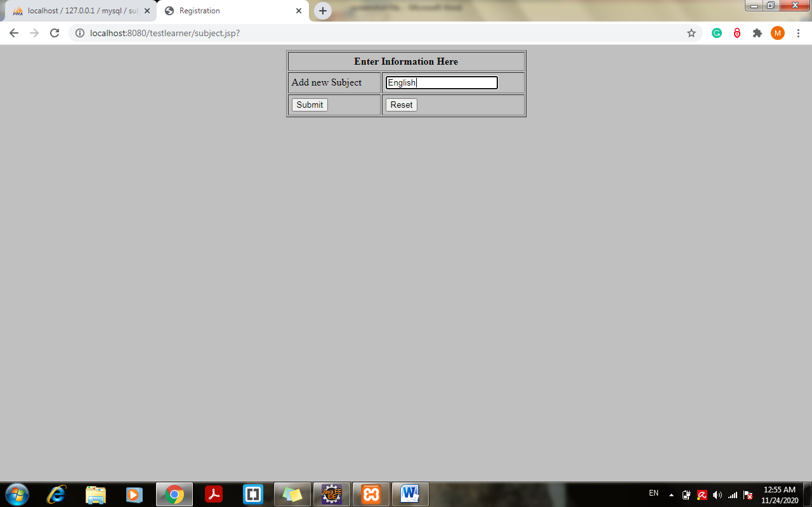

1. New Subject Added Successfully:

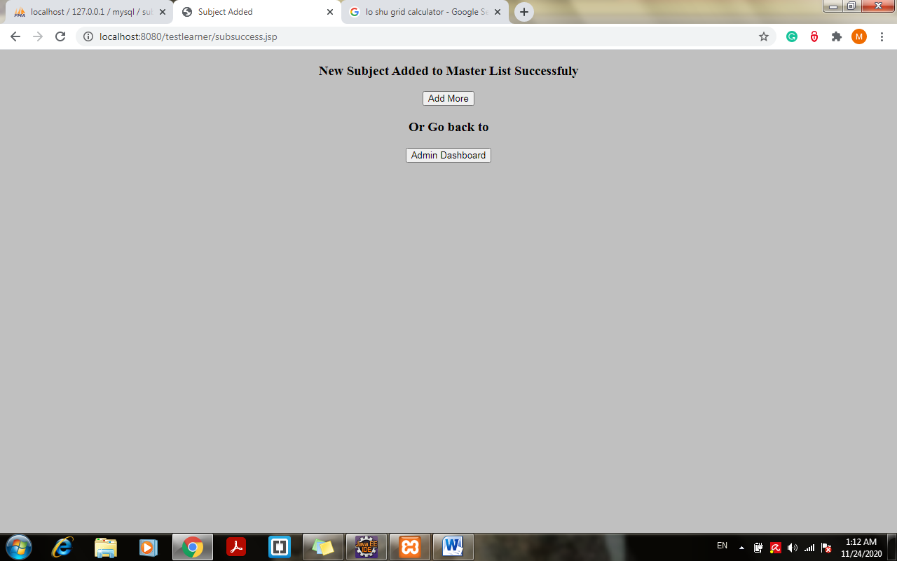

1. New Subject added to the database:

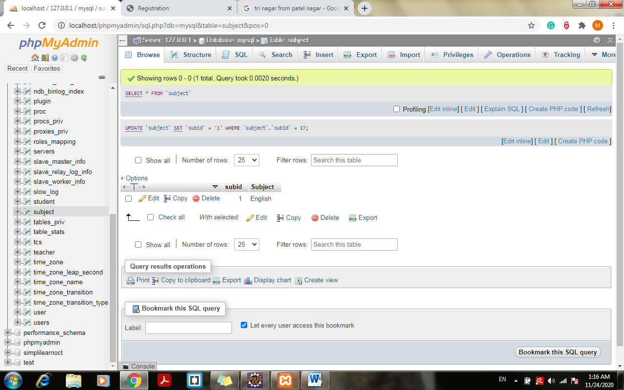

1. Try to add same subject again:

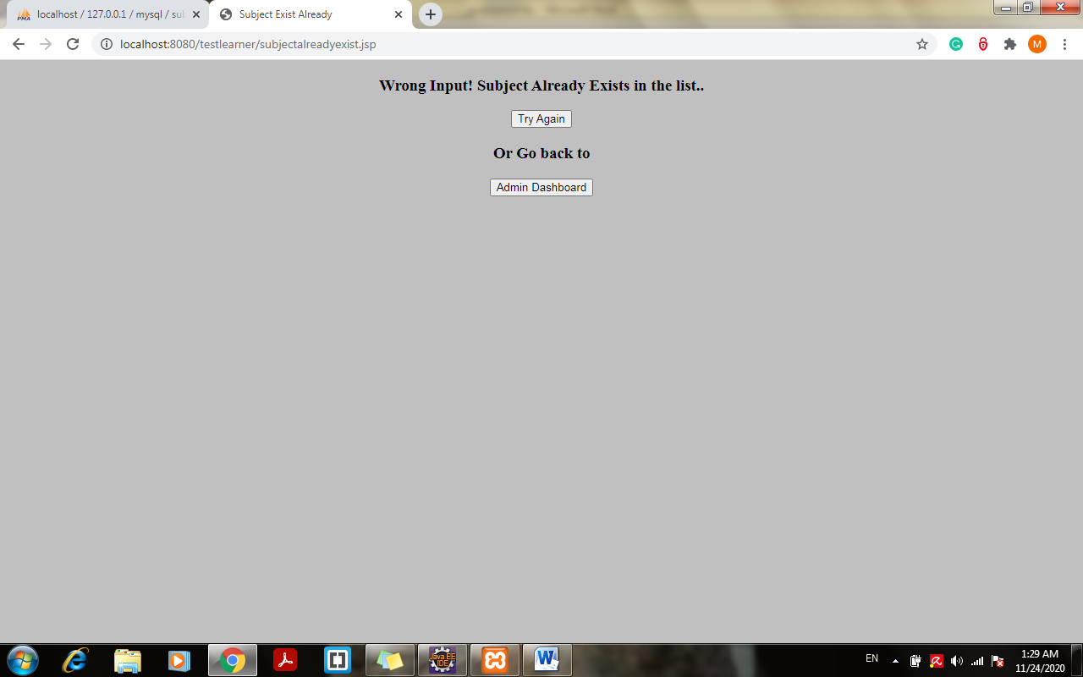

1. Click on try again and add new subject and click submit:

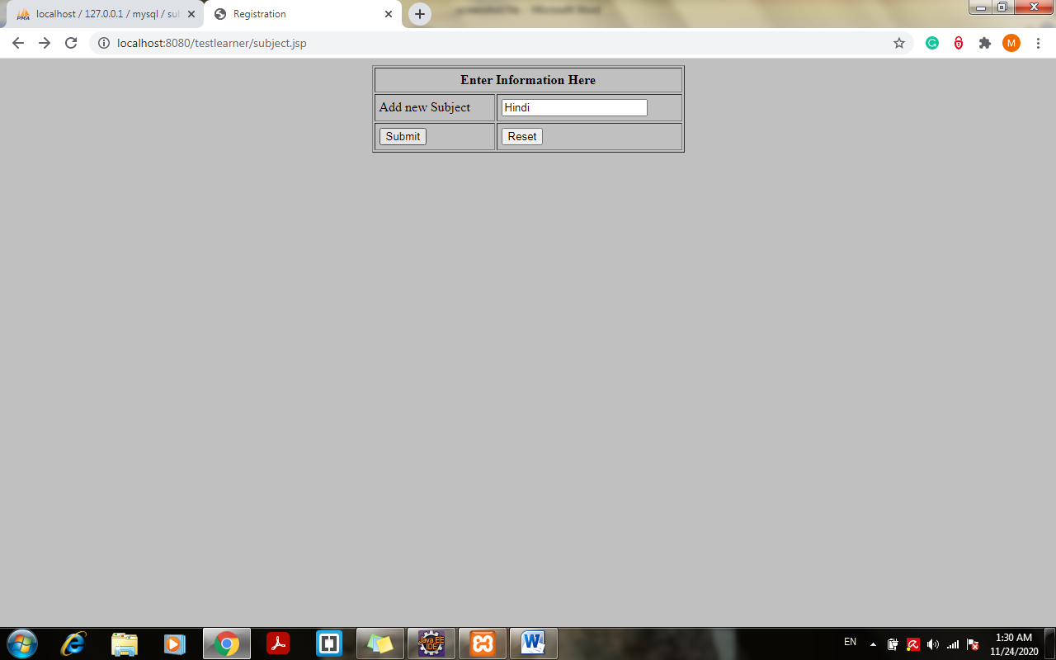

1. New Subject Added to the database:

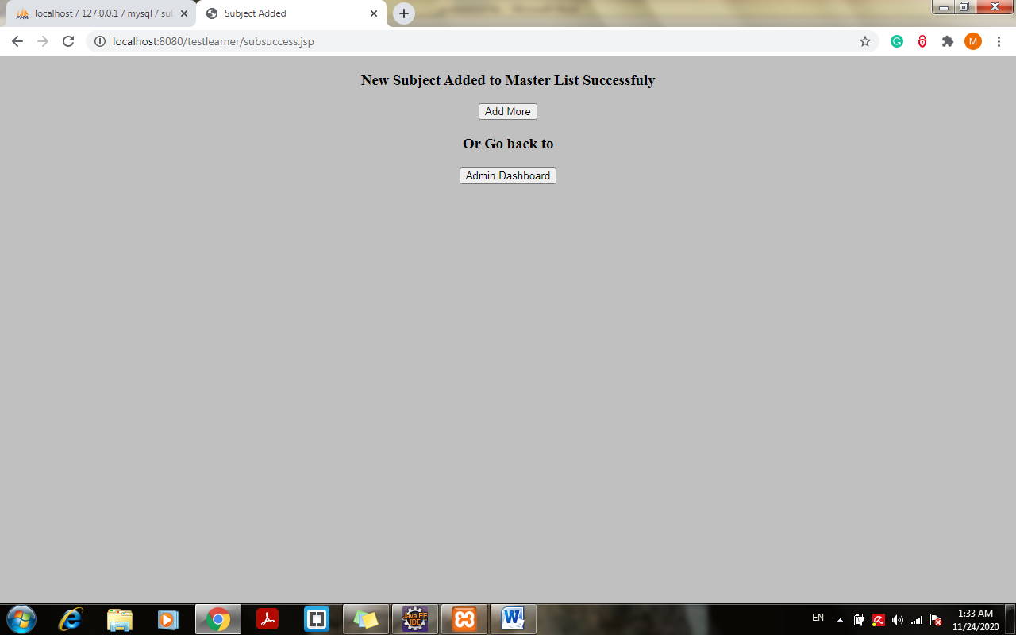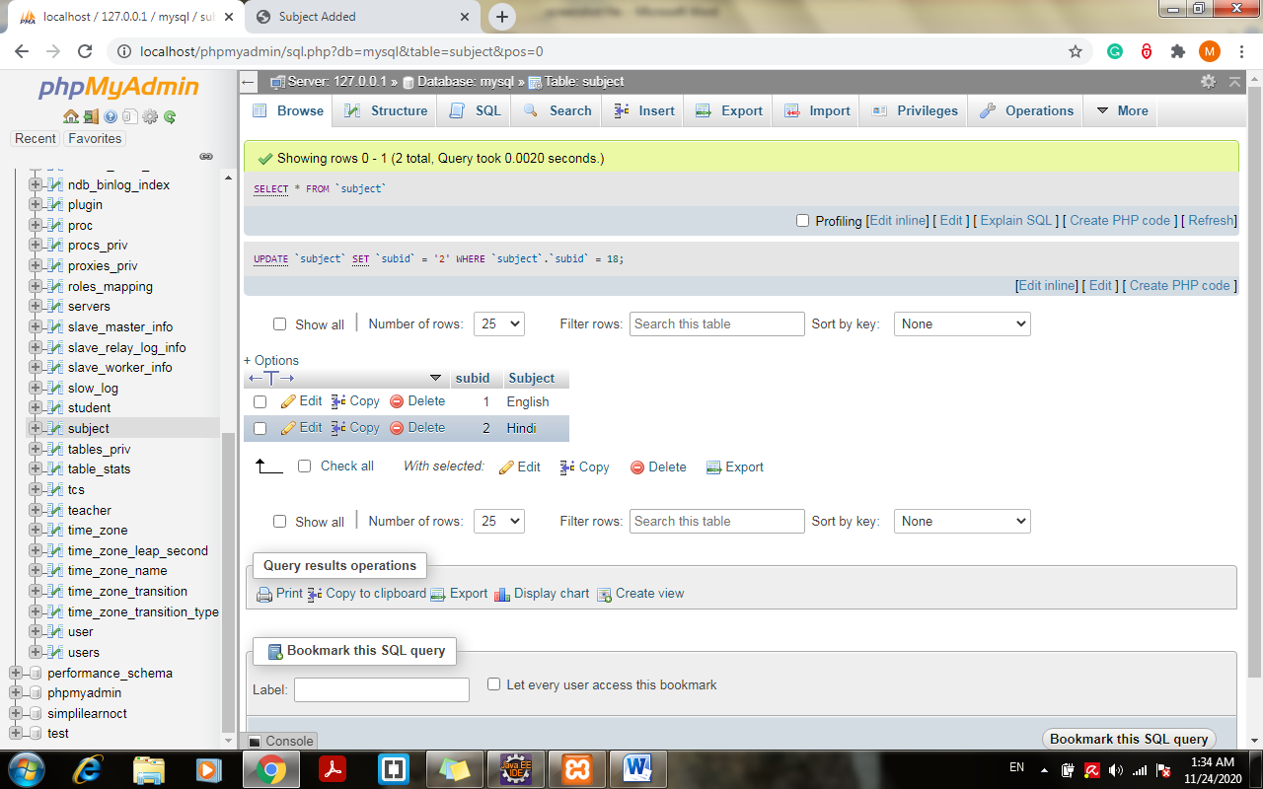

1. Choose set up master list of all teachers and add new teacher:

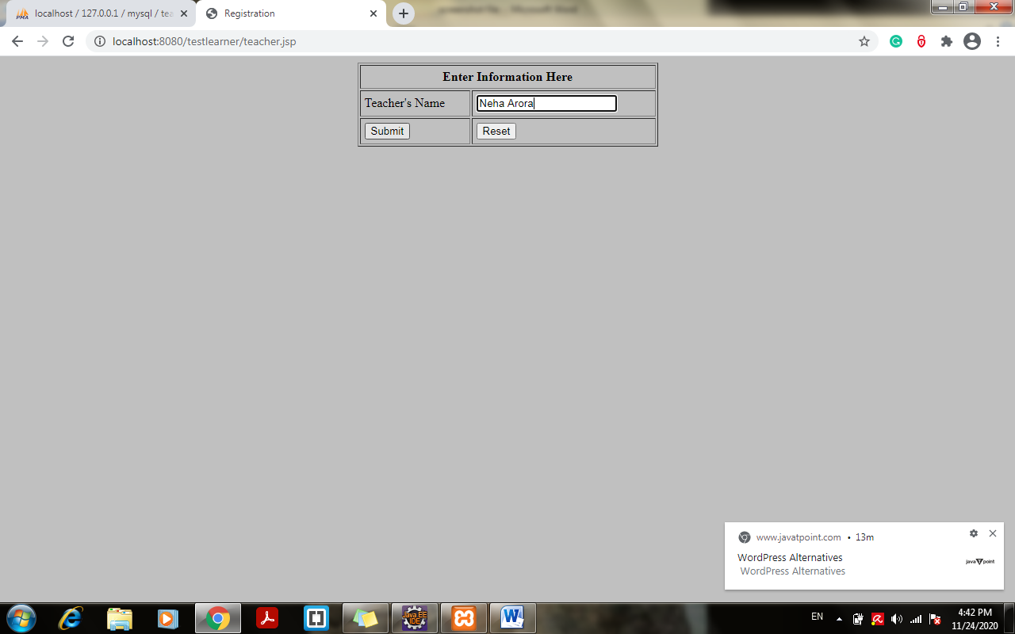

14. Improvisation on code with display of master list of Teachers on same page with delete option:

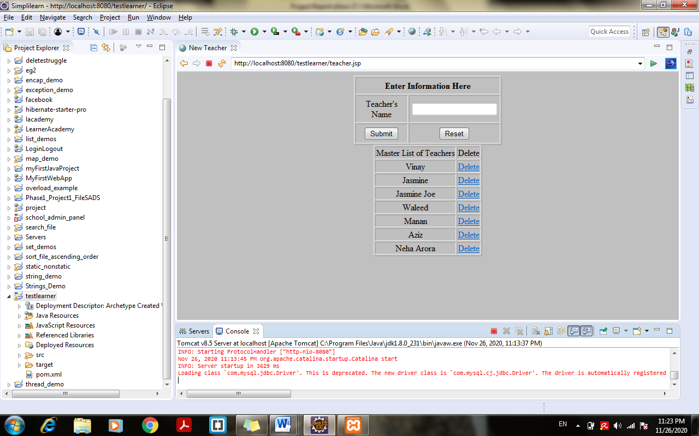

15. Try Deleting Teacher example “Neha Arora” > Click on delete :

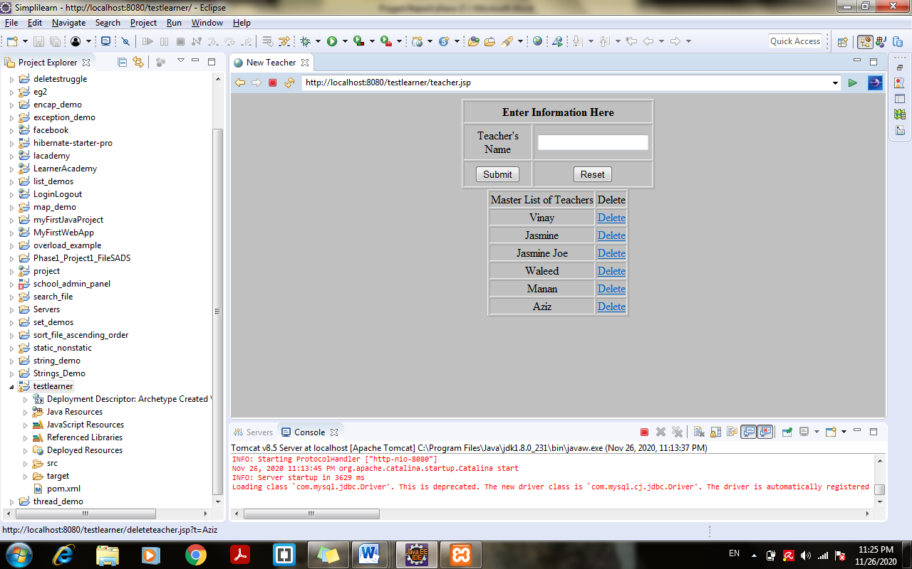

1. New Teacher added to the teacher table in a database:

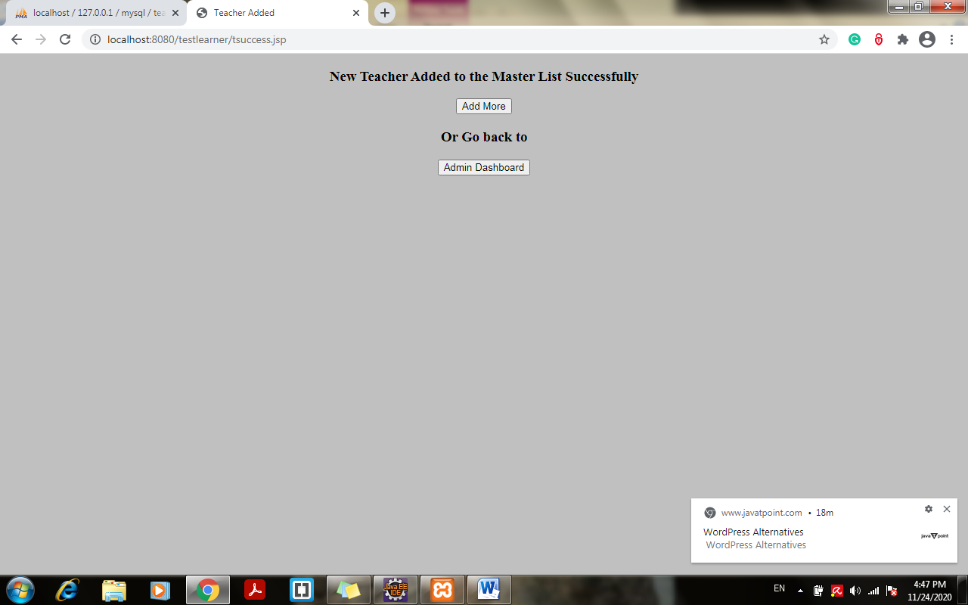

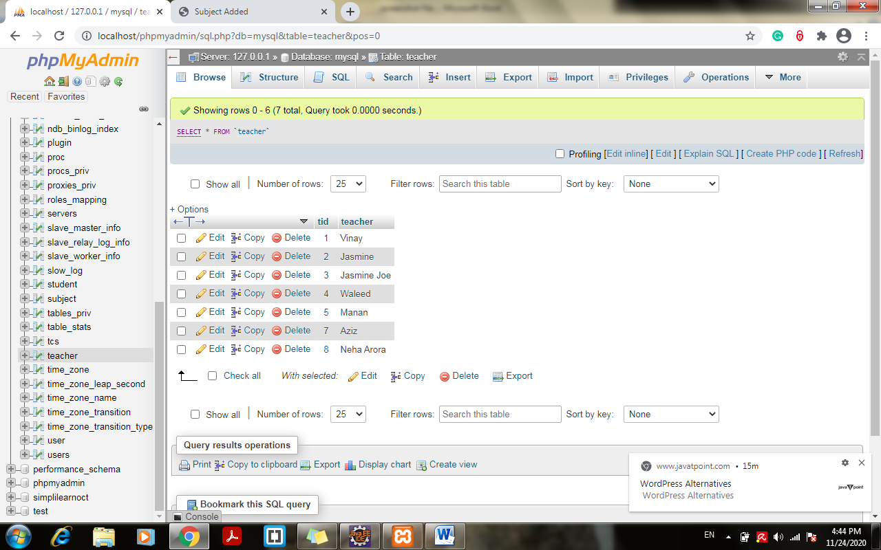

1. Click on add more and try adding teacher already exist in list:

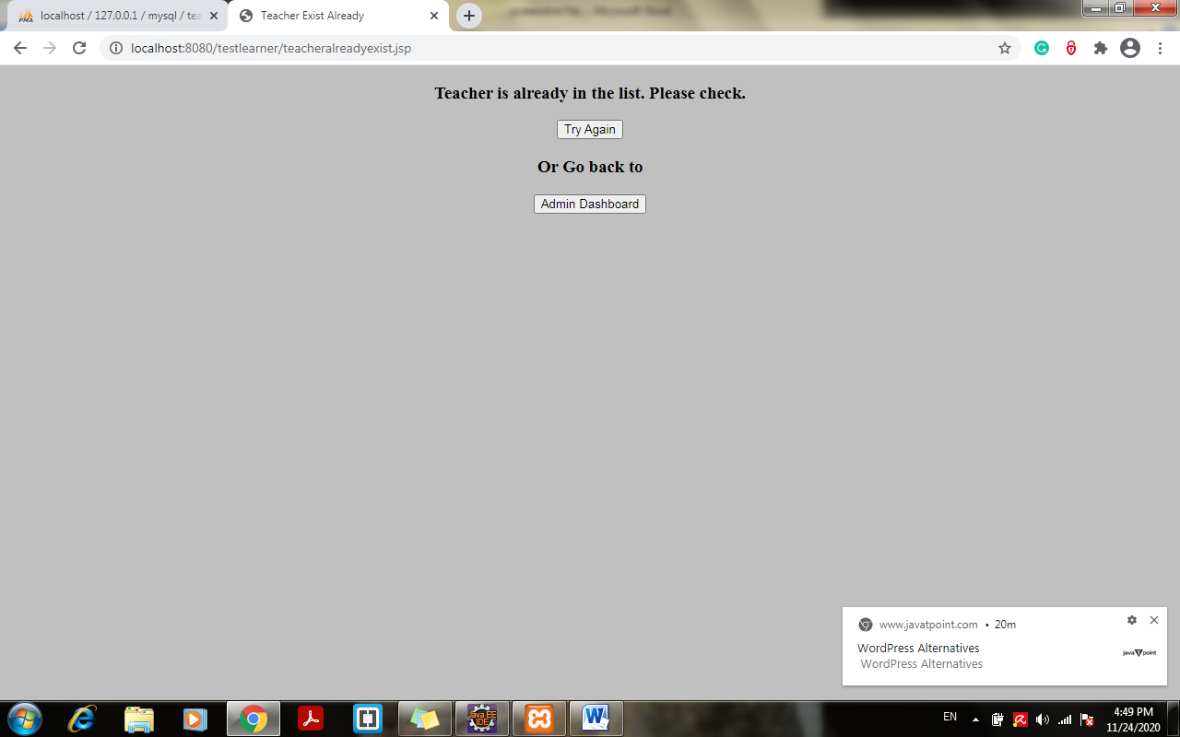

1. Enter a class already exist in table shows class already exist:

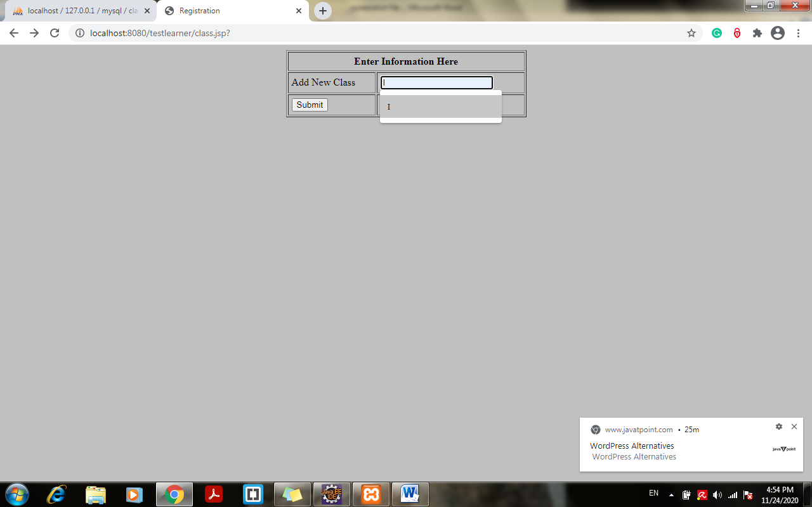

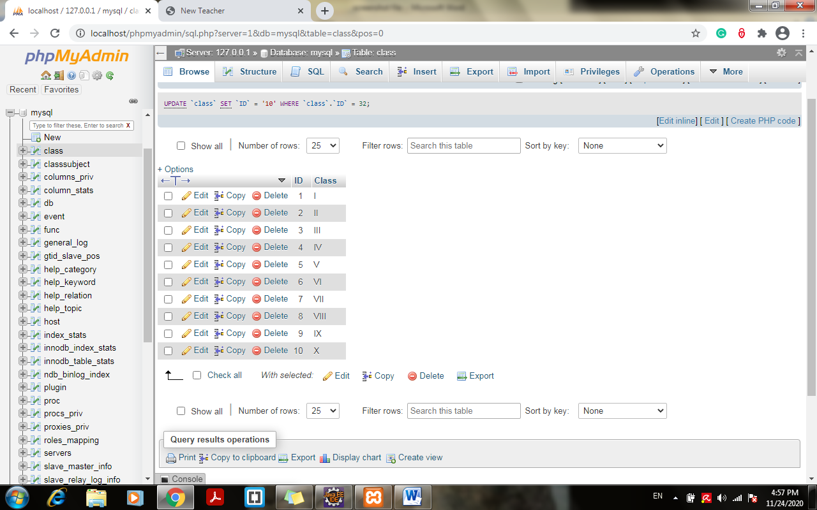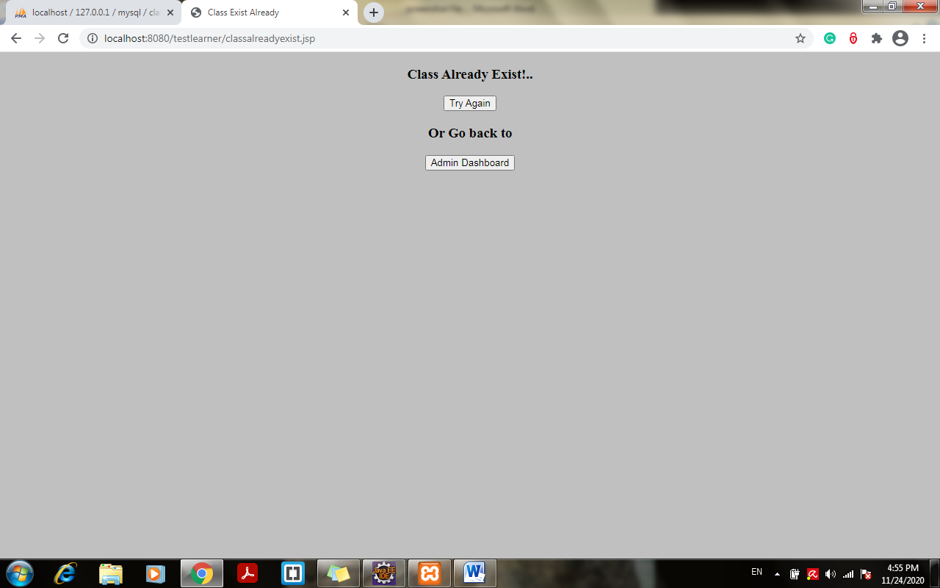

1. Click on Try Again and try adding new class:

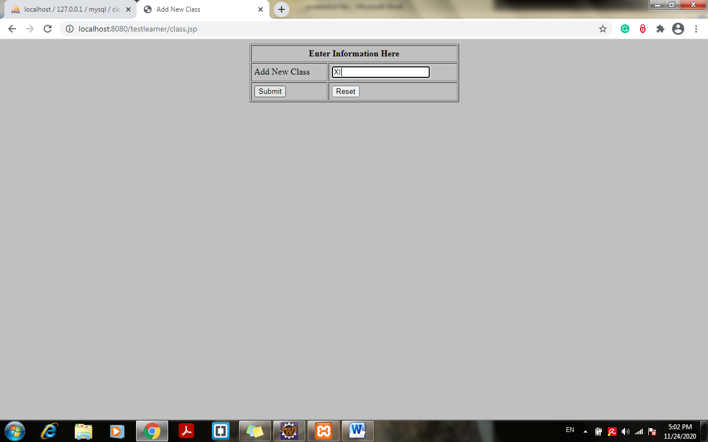

1. New Class Added Successfully in the class Table:

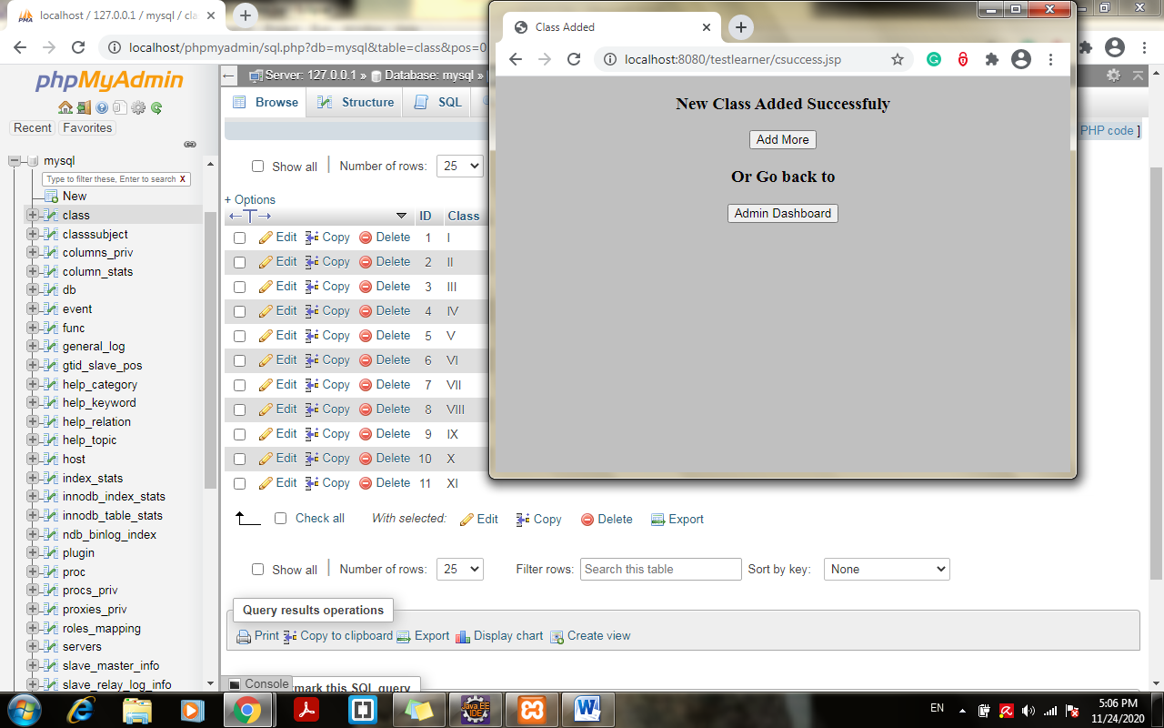

1. Assign classes for subject taking dynamically from class table> choose class:

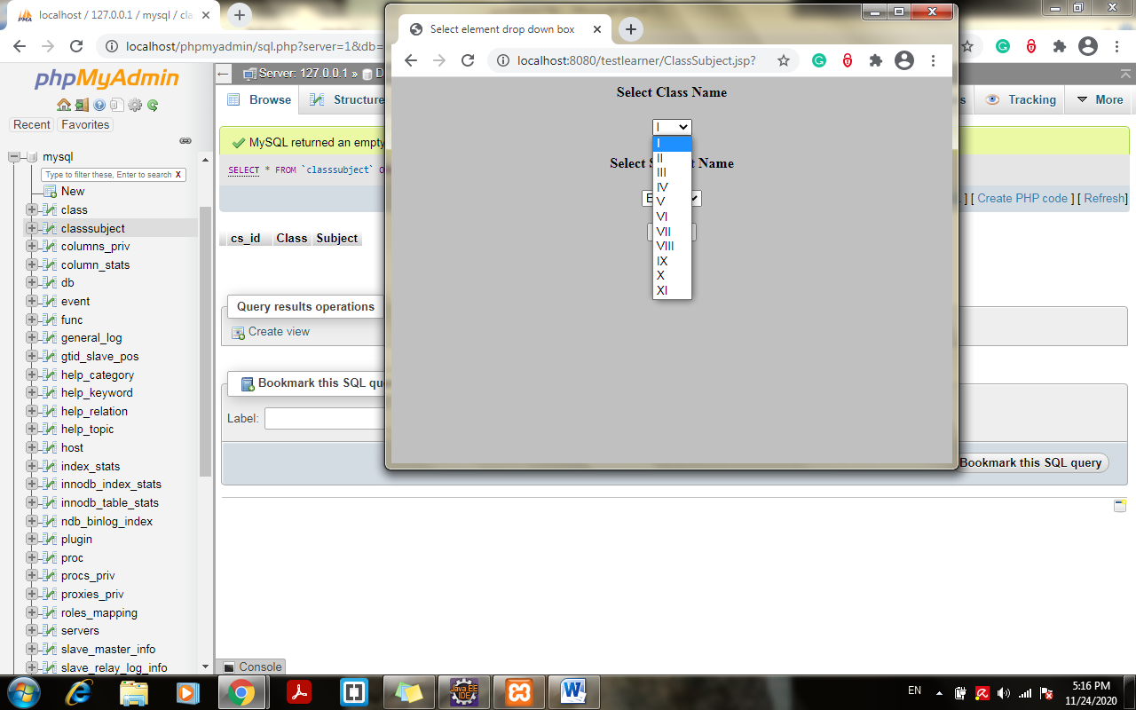

1. Choose Subject from subject table an click on assign:

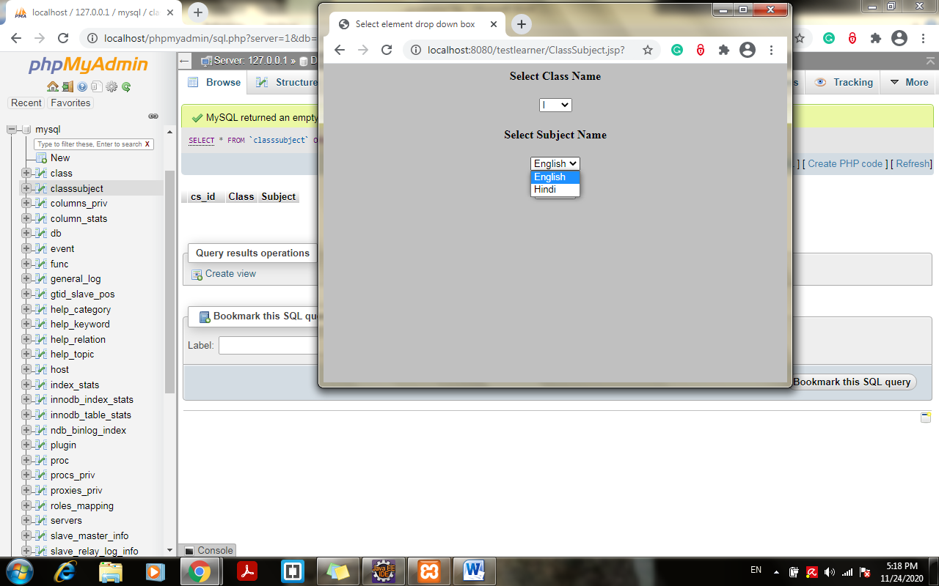

1. Subject assigned to class successfully.

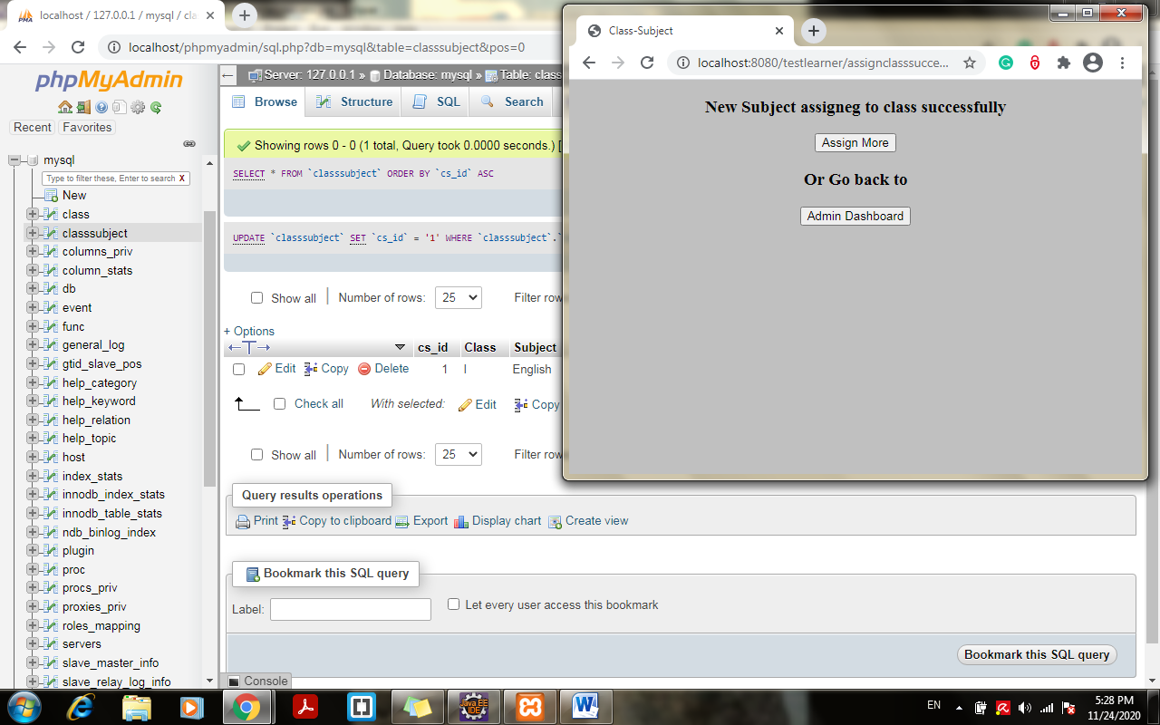

1. Code Improvisation with master list of all classes on same page below the new class add box:

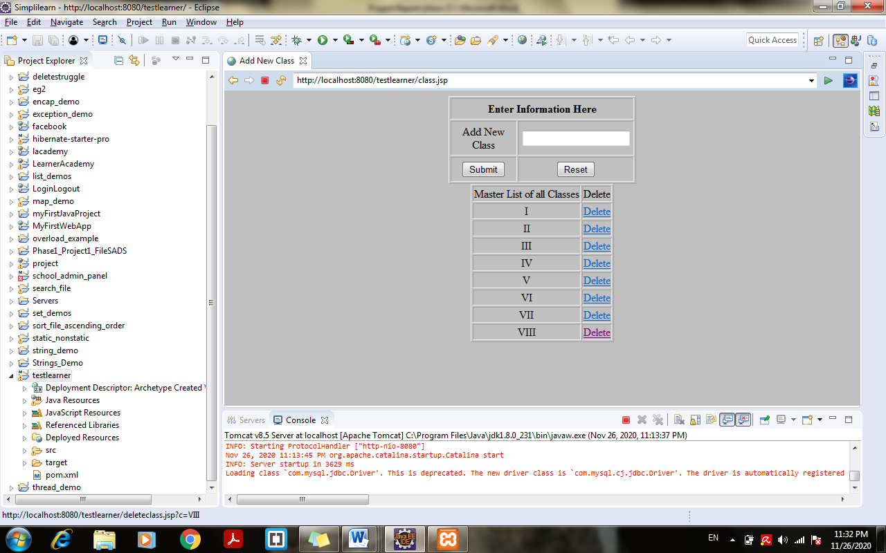

1. Try deleting class example “VIII” > click on delete> class delete on same page itself:

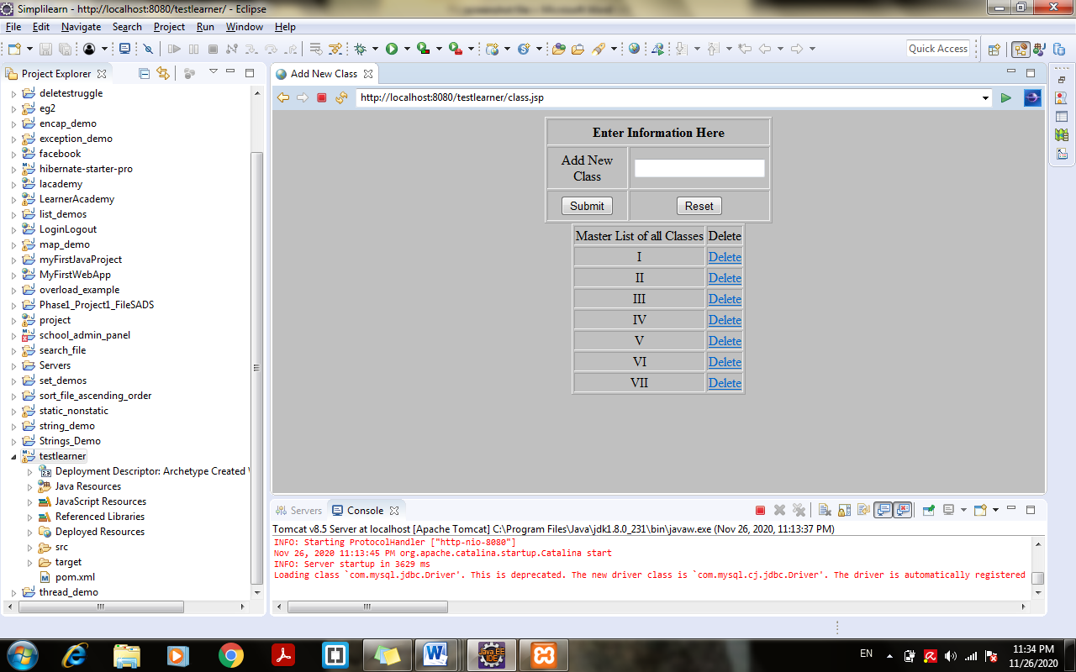

1. Click on assign more and try adding same subject to same class:

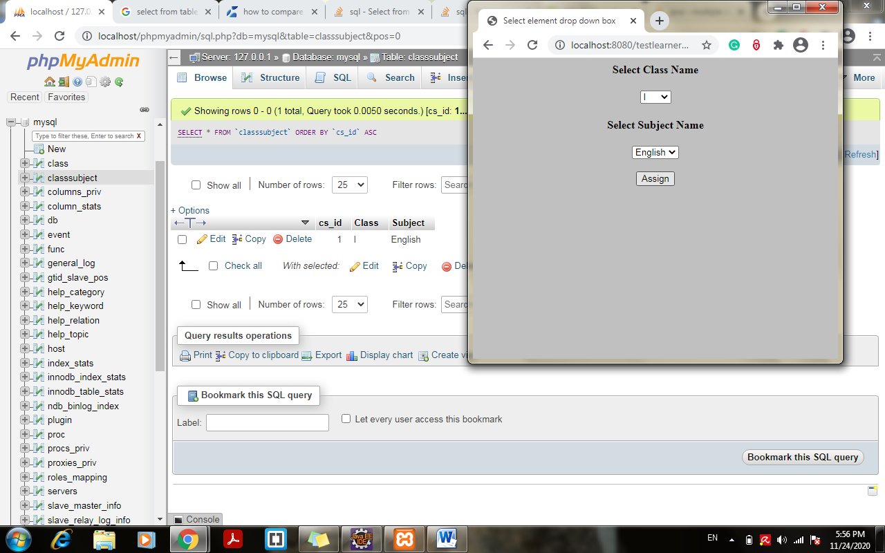

1. With above option will show error> class already exist:

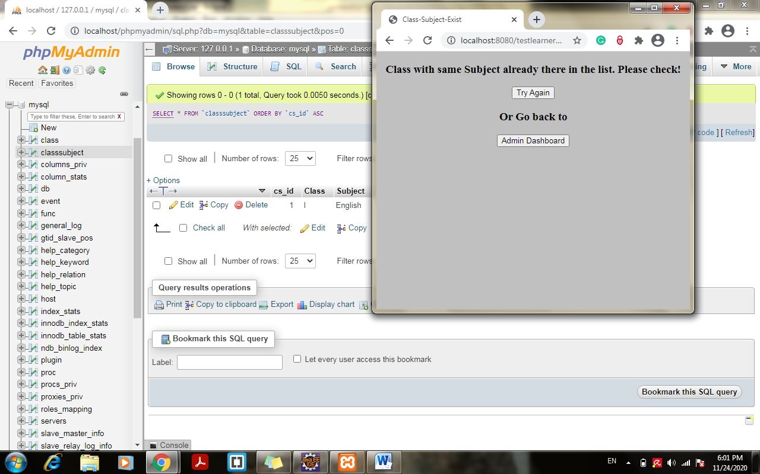

1. Select > assign teacher to class for a subject > choose class , subject and assign a teacher to it:

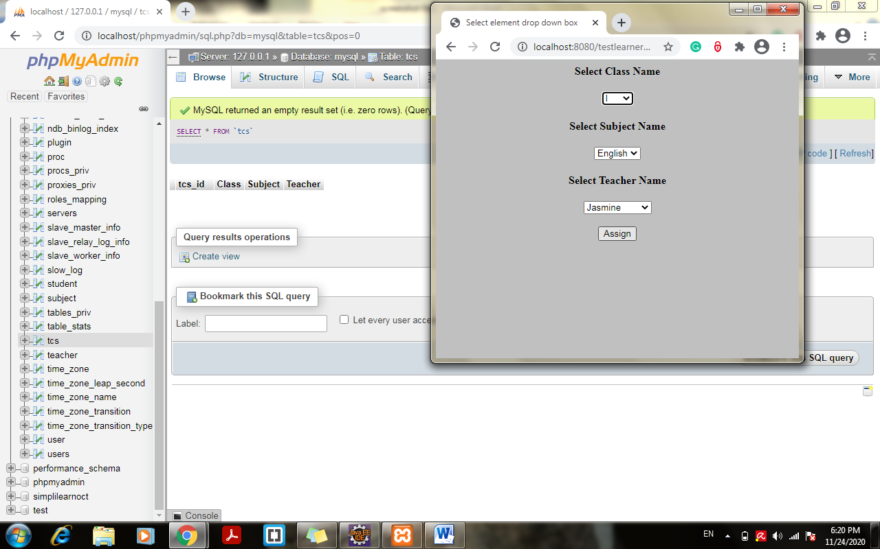

1. Teacher assigned to class with subject successful:

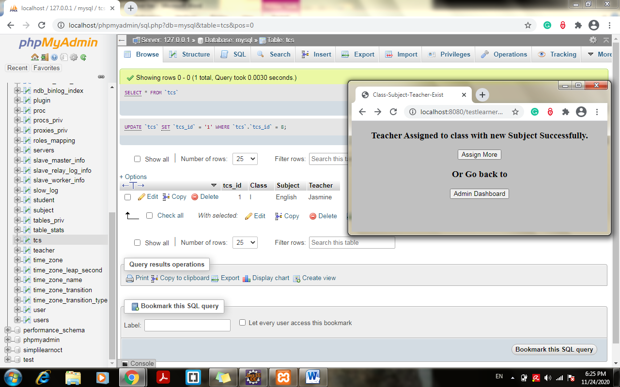

1. Try Adding with same input again:

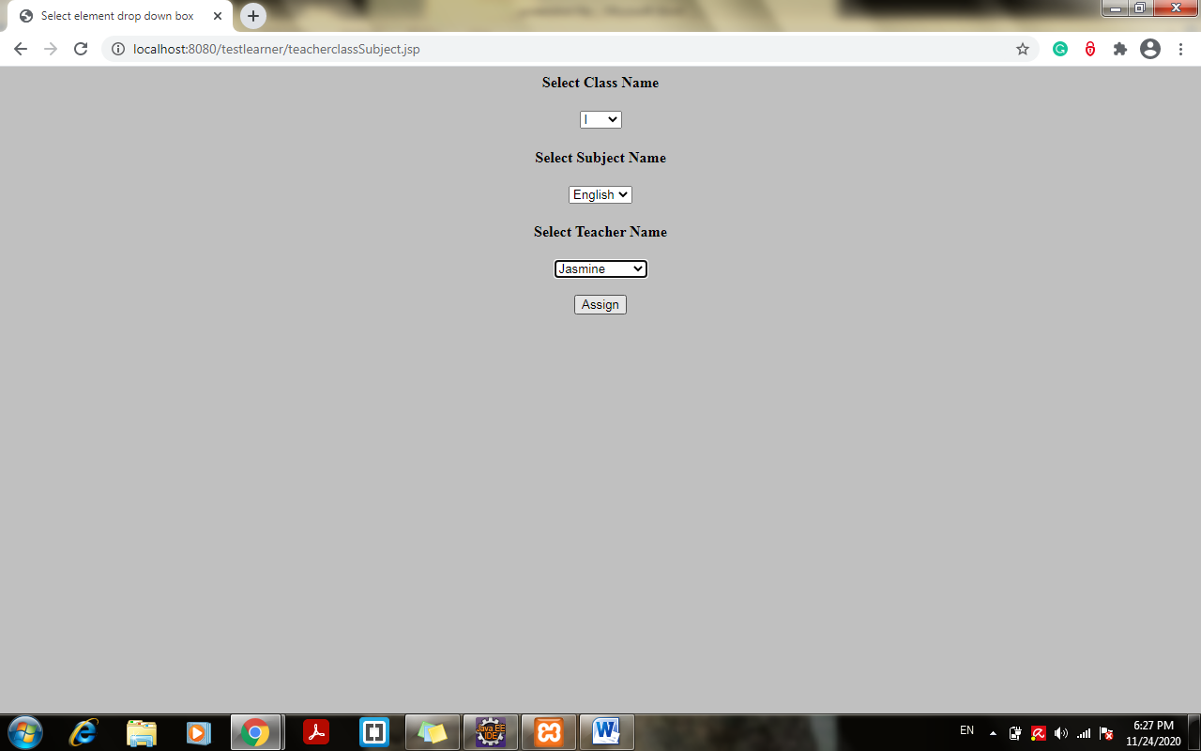 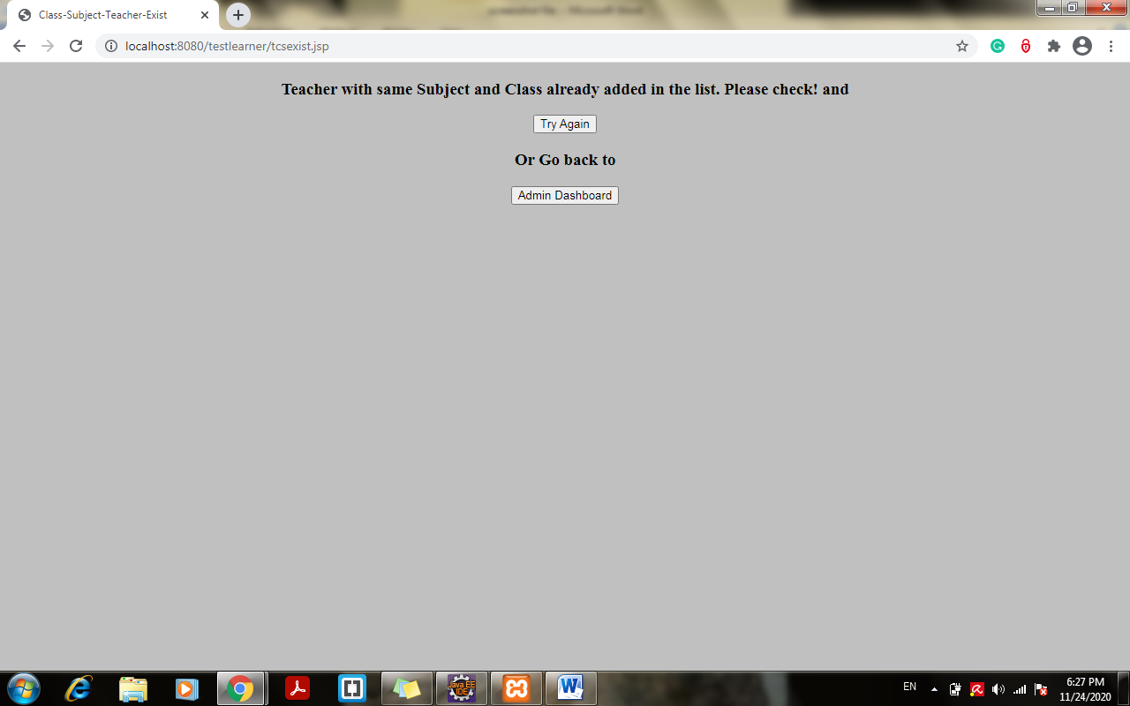

1. Try Giving new subject to same teacher for same class:

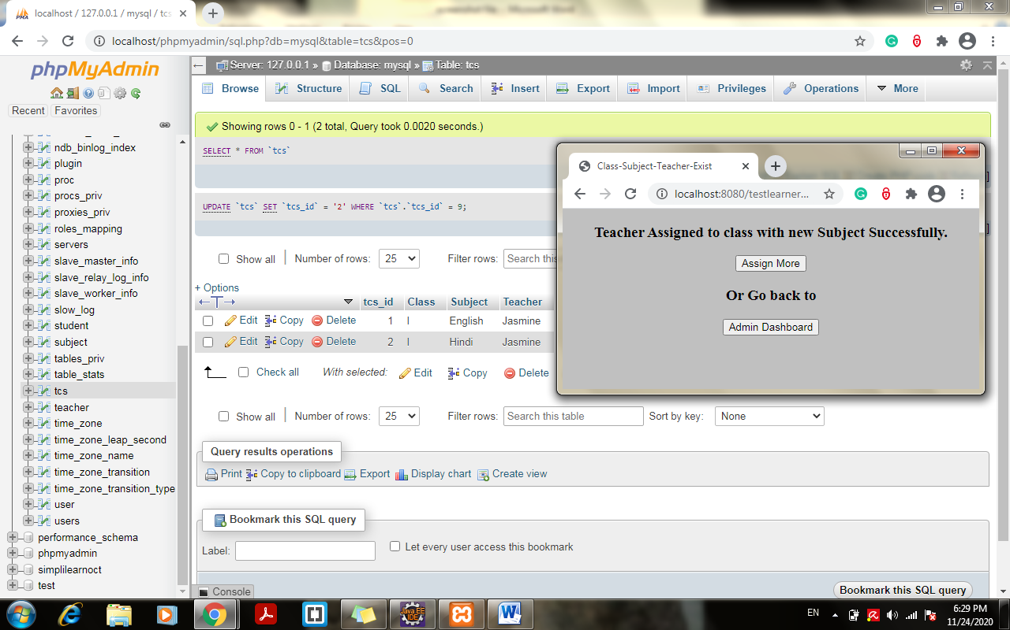

1. Choose different class same subject same teacher:

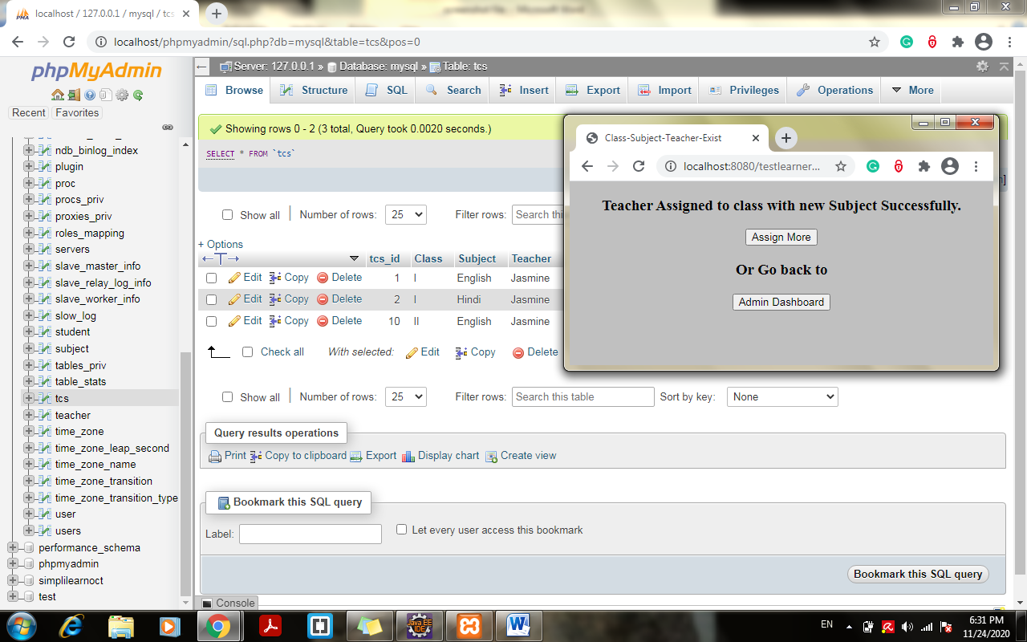

1. Select same class different teacher different subject:

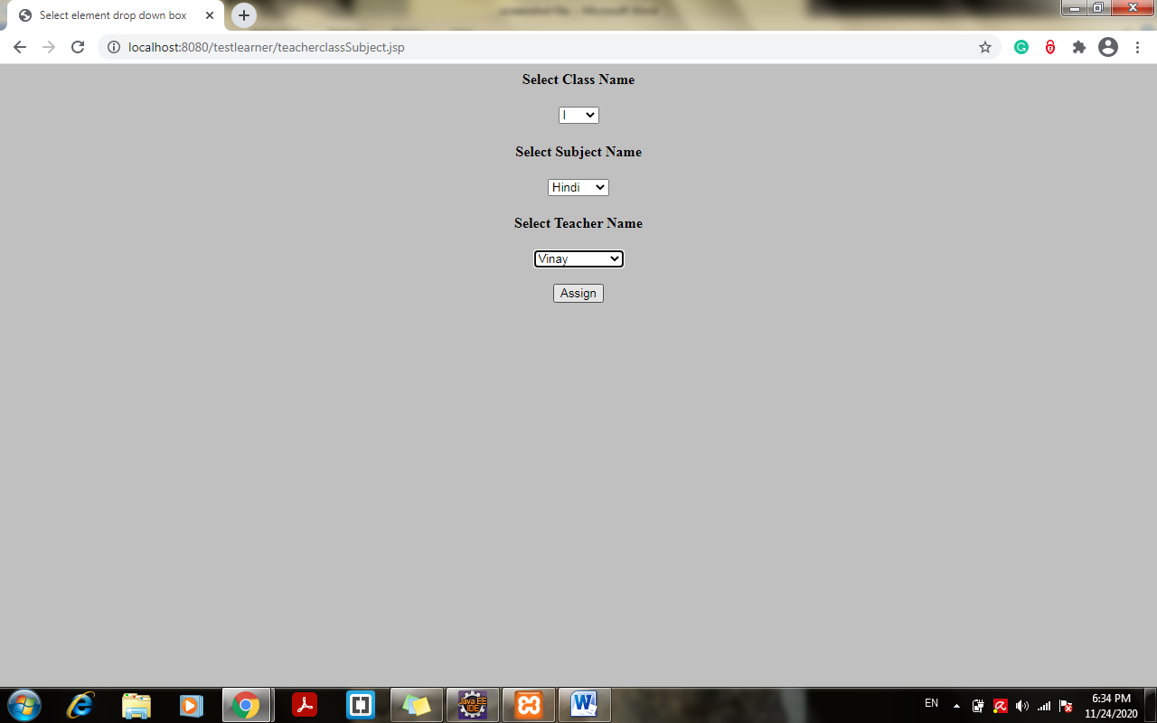

1. Different teacher assign to different class with different subject:

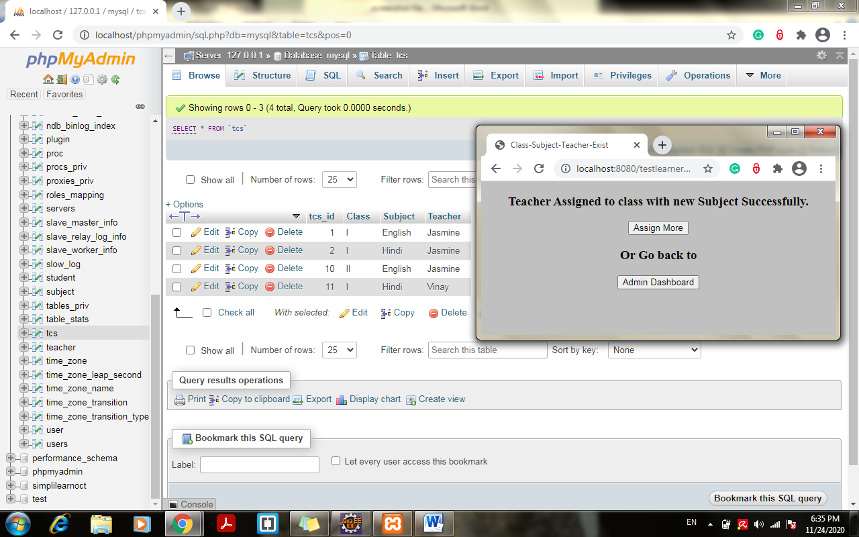

1. Click on option add student and assign a class:

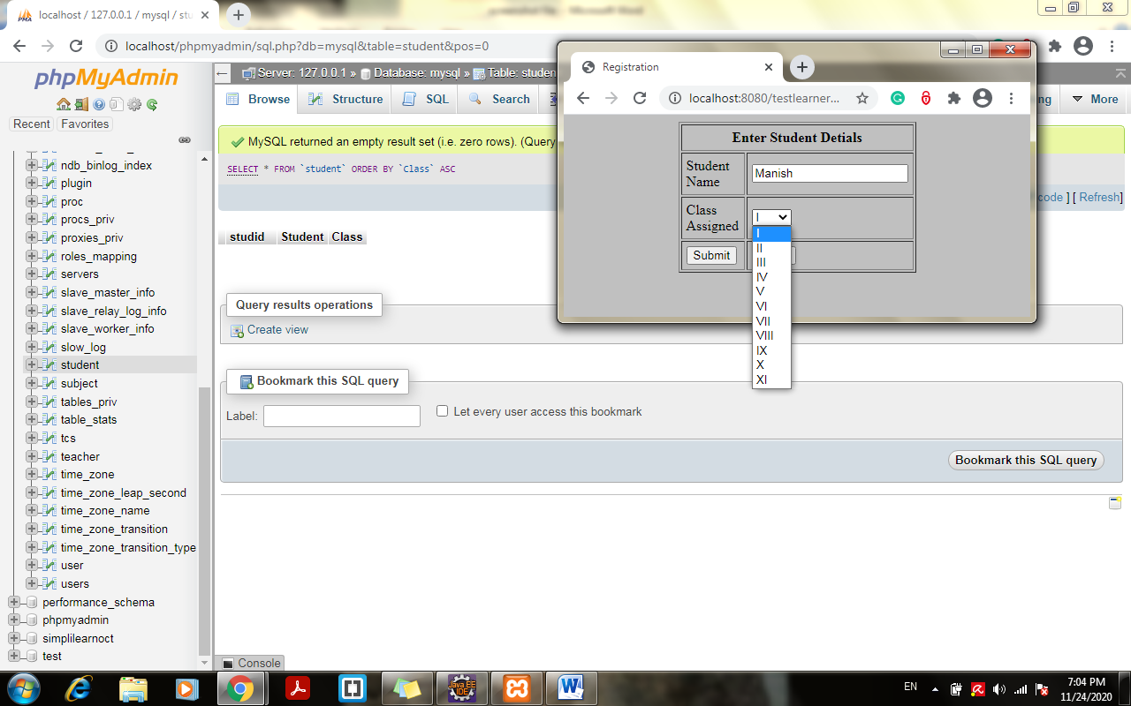

1. New Student added successfully:

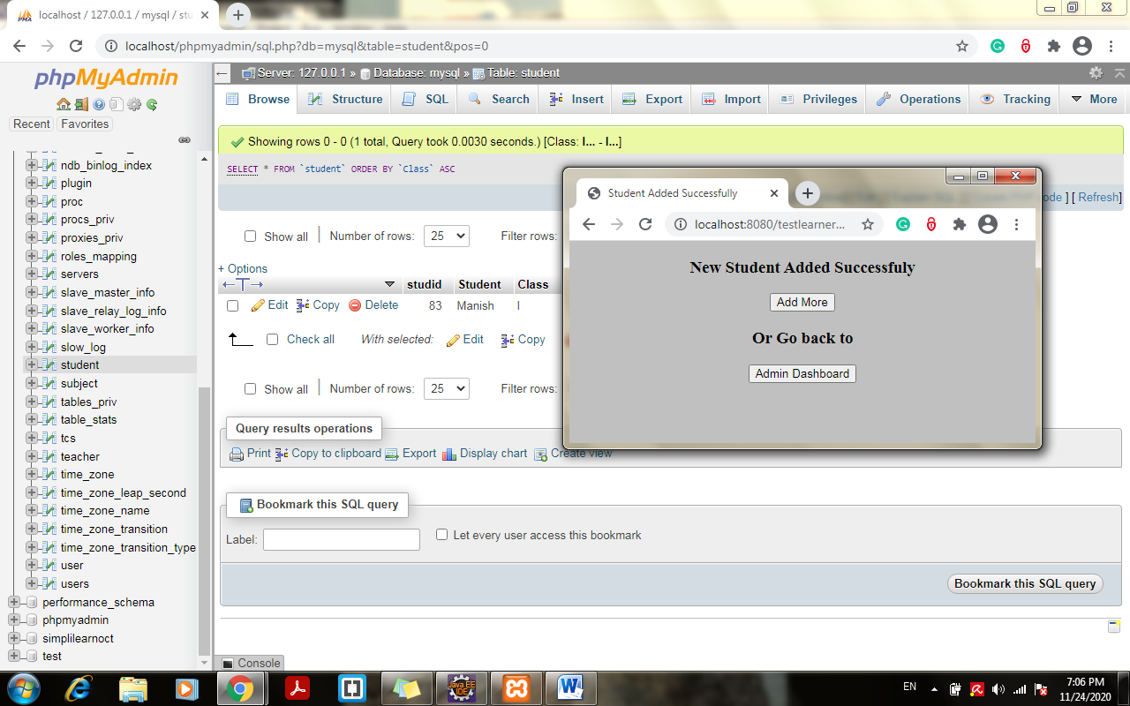

1. Click on add more and try adding same student to same class:

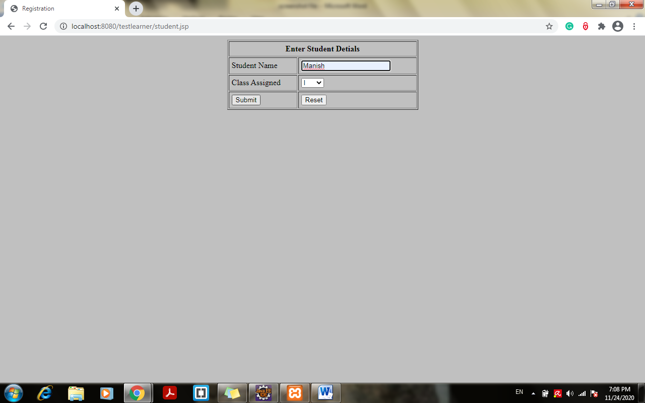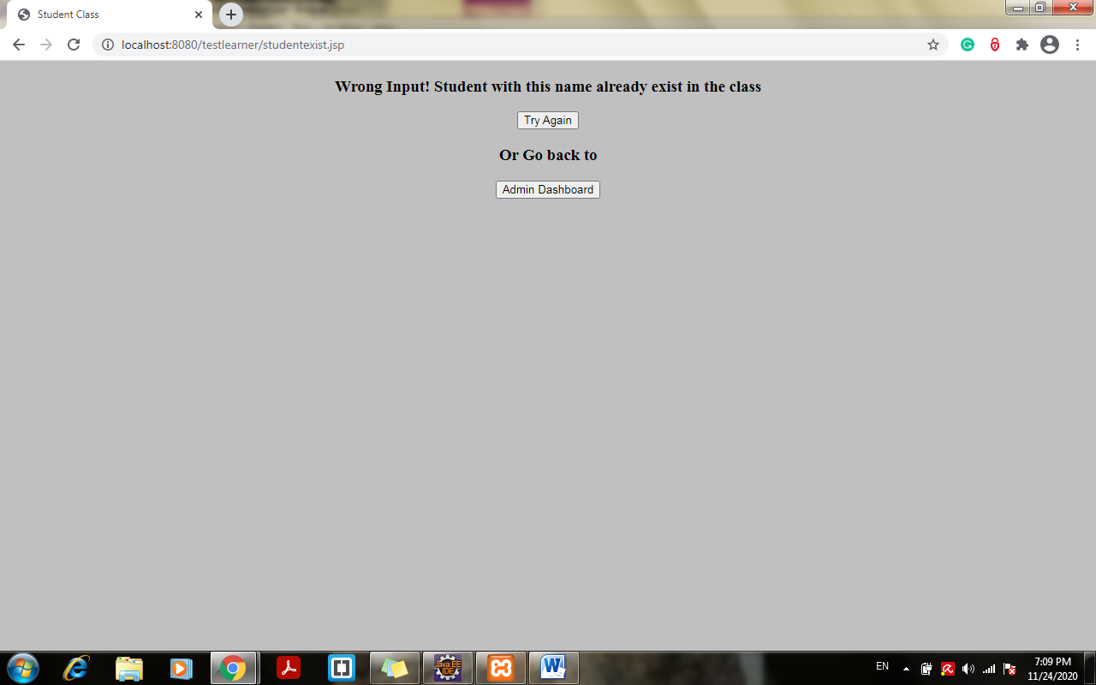

1. Try adding new student:

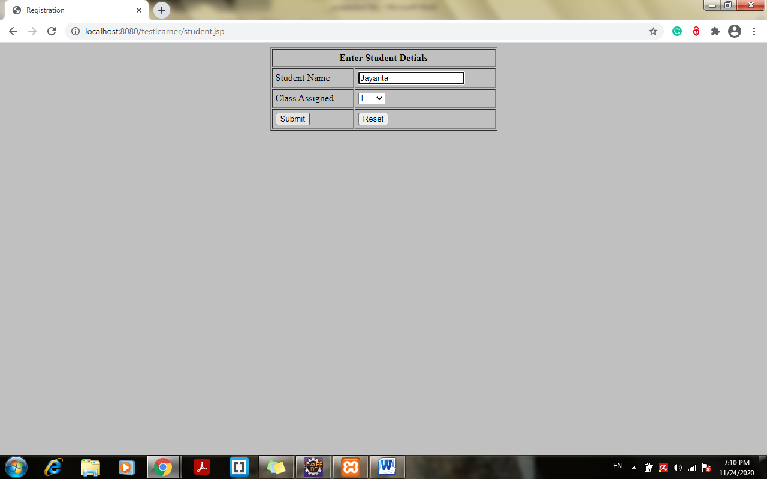

1. New Student added:

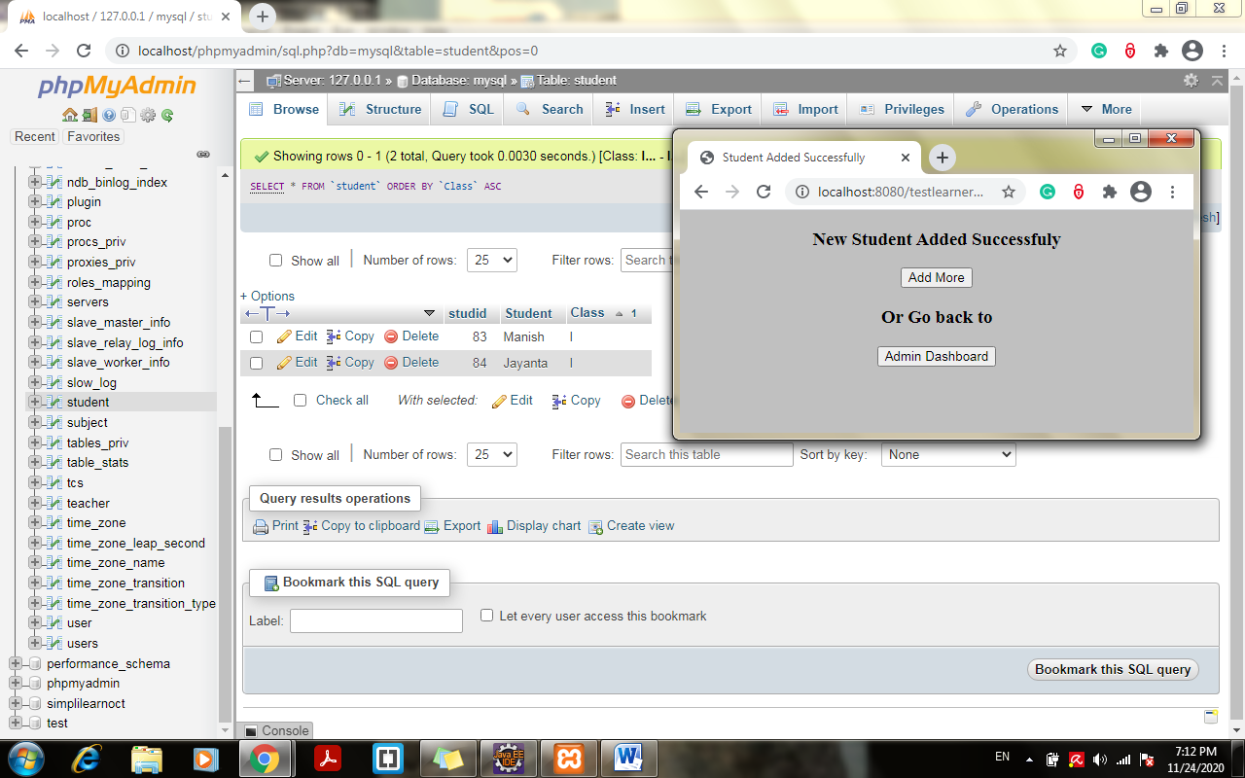

1. Click on get master list of students < choose Class from scroll down and click on get student list:

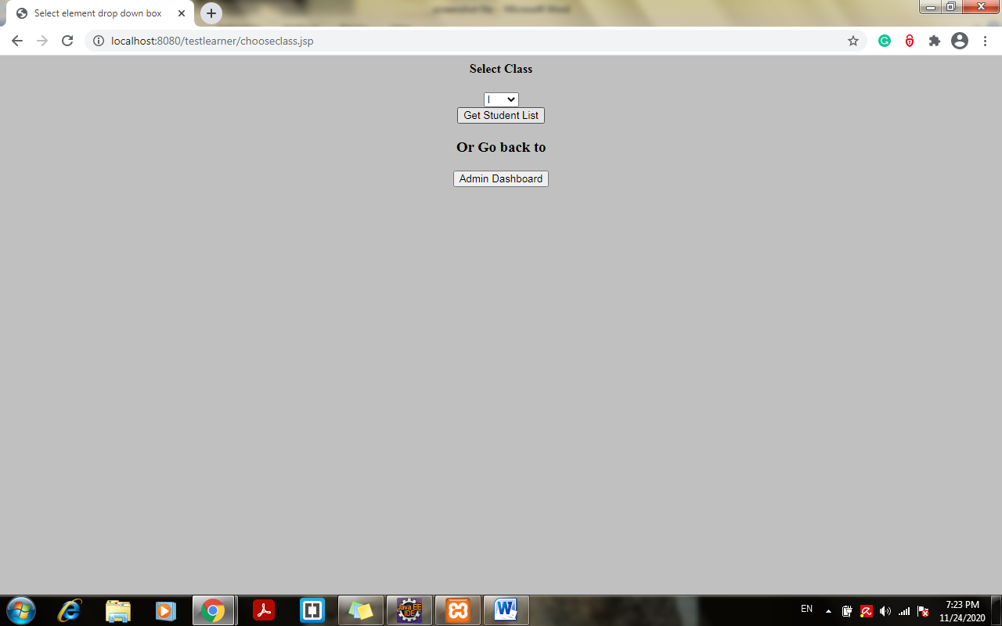

1. Student added with earlier operation to table fetched from student table:

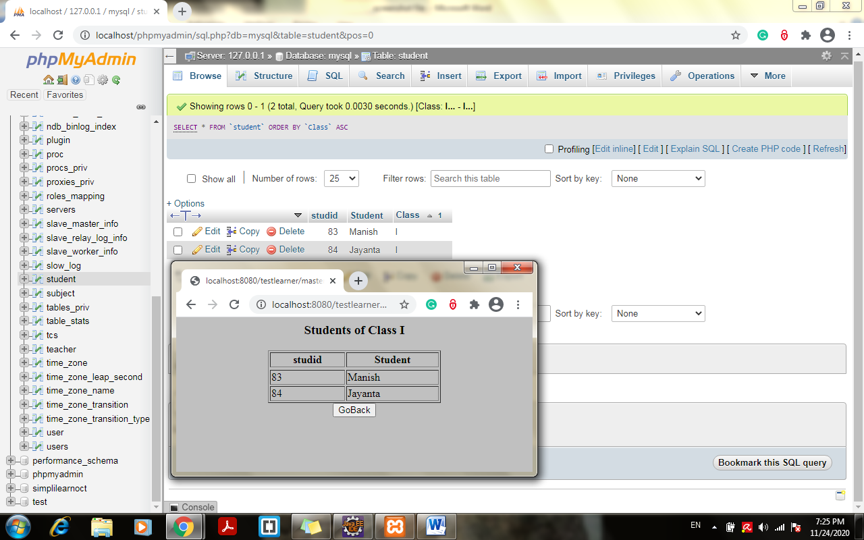

1. Go back to the dashboard > choose last option to view class report> choose class and click on generate report:

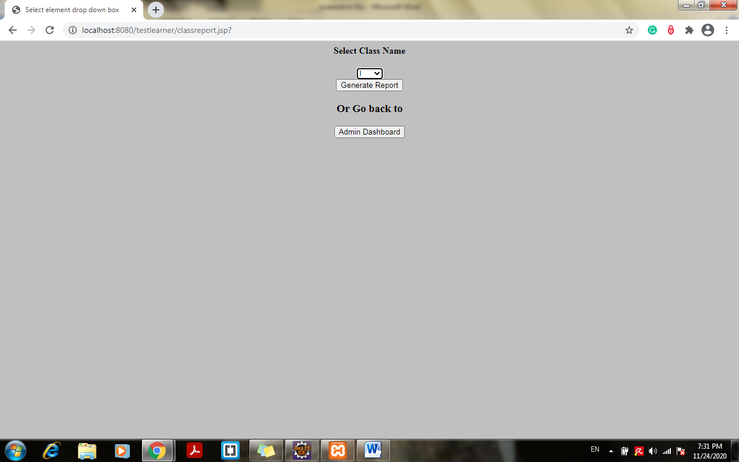

1. Data added with earlier operations fetched from database and displayed:

